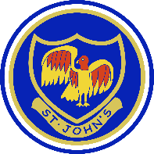

Home learning Week beginning 15 June 2020
Edison Year 1
Please look on the Home learning hub Class 1 for all the attachments. Thank you.
Remember to share your lovely work on the Padlet wall.
https://padlet.com/hkeane61/us6ytz9qea22mtcx
Window walk’ Put your lovely things in your front window, so all your friends can see what you have been doing when they go for a walk.
Maths activities | Reading activities
Look on the previous Home learning plans for online maths games we have been using.  Use www.topmarks.co.uk to play different maths games.  Use your LGFL USO username and password to login to Busy things for lots of fun maths games.  https://www.busythings.co.uk/play/  NEW MATHS ACTIVITIES  Movement  Play a game with your family. Take turns to say different instructions- include whole turn, half turn, quarter and three-quarter turn.  With the describing turns worksheet- cut out extra shapes to help the children visualise the turns.  Look on the HOME LEARNING HUB Class 1 for the Math’s worksheets. | - Keep reading lots of different books at home.  - Please read every day and share a book with an adult.  - ‘Audible stories’ is a free website where children can listen to lots of different stories. You can use the link below.  https://stories.audible.com/start-listen  - Oxford Owl – use my class login. My Book shelf. Click on a book. Listen to the story and play activity 1 and 2.  NEW READING ACTIVITIES  See if you can find any information books on space. We are going to be learning about Neil Armstrong and his journey to the moon.
Phonics activities | Writing activities linked to our Explorers theme.
- Do phonics every day- Please see the attached phonics worksheet.  Remember to do your sound buttons and underline special friends. You can do a wiggly line to remind you to blend sounds. For example, br cr fl bl.  Remember to give yourselves a ‘rainbow clap’, a ‘Fan..tastic’! and a ‘hip, hip hooray’!  .  Grammar Plurals- add s and es  Look on the HOME LEARNING HUB Class 1 for the worksheet. | Neil Armstrong  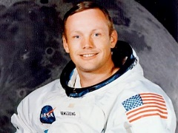  Use the PowerPoint (HOME LEARNING HUB Class 1) and video link below to find out about Neil Armstrong and his journey.  https://www.bbc.co.uk/bitesize/topics/zjwvb82/articles/zhx4k2p  Complete the timeline of the life and significant achievements of Neil Armstrong. (HOME LEARNING HUB Class 1)  Write about Neil Armstrong.  Use the writing template (HOME LEARNING HUB Class 1)  Write two or more facts about the moon.
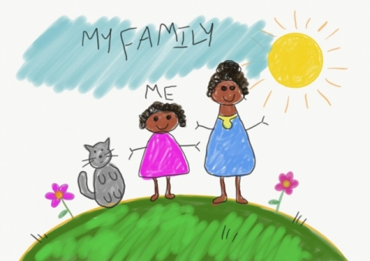
RE Sikhism. What do Sikhs believe? Use the link below to find out more about Sikhism.
https://www.bbc.co.uk/bitesize/topics/zsjpyrd/articles/zkjpkmn

SCIENCE Use the link below to watch a short clip about the seasons.
https://www.bbc.co.uk/bitesize/topics/zkvv4wx/articles/zcx3gk7
Fold A4 paper into 4 sections. Draw a picture of a different season in each section. Label your drawings autumn winter spring and summer.
ART/DT Design and make your own rocket using different materials. 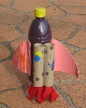 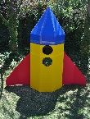
Paint your own space picture. Splatter paint the paper by gently tapping your paint brush to create a space background. Cut out planet and star shape templates. Paint them and stick them on your paper.
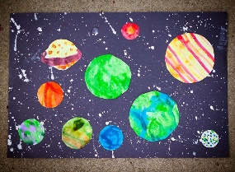

OWL – Outdoor and wilderness learning ideas. Parents you can use the subscribe button on the hub and follow Forest school on social media (Facebook, Instagram, Twitter @forestschooling if able) to receive updates on the learning challenges.

https://owlfamily.co.uk/fun-things/

Sharing your lovely work!
Click on the Padlet link at the top to upload a photo of your work this week.
PLEASE REMEMBER NO NAMES OR PHOTOS OF CHILDREN- USE YOUR NUMBER.
To upload a photo of your work – open a text box. Remember to click on the pink round plus sign in the bottom right hand corner of the Padlet wall. Once you click on that pink sign your text box will appear. Now click on the first icon (an arrow pointing upwards) in your text box, ‘Pick file’ will appear, so you can find where you saved it on your computer. Select and upload it.
Coronavirus and Wellbeing- Looking Forward
The change that Covid-19 has caused to our lives has been difficult and has provided countless challenges. For many children, the uncertainty and disruption to everyday life has caused worry and anxiety. These tasks are designed to help children process the current situation, begin to make sense of it and plan for returning to a different normal.

Think
Reading or being read to offers hope and positivity. The Book of Hopes aims to comfort and encourage children during these unusual times.
Talk
Talk to your child about what they are looking forward to most when things begin to return to normal. Who are they looking forward to seeing at school? What places are they excited about visiting with the family? What will they miss about being at home?
Do
Write the headings ‘Things I’ve enjoyed being at home’ and ‘What I am looking forward to most’ on paper. Ask your child to draw and/or list all the positive experiences they have had over the last few weeks and those to come.
Visit
If your child is struggling to adapt to the ‘new normal’, Mind Ed for Families offers safe and reliable advice on supporting children’s mental health and wellbeing.
Please go to the Home learning Hub on the School website for further ideas.
You can contact me by emailing the school office.
Take care
Mrs Keaney

