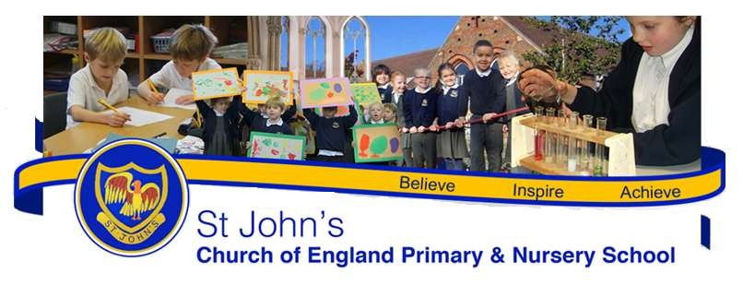
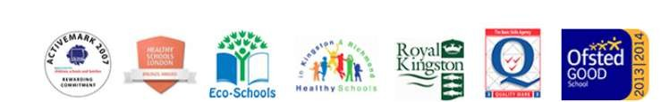

Believe ... Inspire ... Achieve

Prospectus 2019/2020

Headteacher: Mrs Lulu Esua

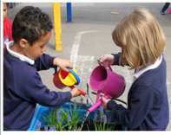
Welcome

St John's Church of England Primary & Nursery School

Welcome to St John's Church of England Primary and Nursery School. We are a one form entry school in the heartofKingstonuponThames.Ihopetheprospectushelpsyougainaninsightofhowourschoolisorganised and to appreciate the exciting opportunities on offer to children in our care. Our School is a welcoming inclusive and caring community of learners. We have strong links with St John’s the Evangelist Church and as well as being a learning community, we are a faith community. We offer excellent support to children and their families and provide an exciting and engaging place to learn within the Christian ethos. Have a look at our newsletters (copies can be found on our website: http://www.stjohns.kingston.sch.uk/lettersto see all the interesting things we have been learning about. We believe that children learn best when they are excited by what they are learning about. We are lucky at St John's that we can take advantage of the many community links which add breadth and depth to our curriculum. We have strong links to The Rose Theatre, St John’s Church, Stanley Picker Gallery, Kingston Grammar School, Kingston College and Kingston University. Children of all abilities flourish at St John’s; our expectations for children are high and the hard working staff do all they can to ensure each and every child succeeds. Children are proud to attend our school; they achieve highly and behavewell.

Our school was last inspected by Ofsted in June 2018 when we judged to be ‘good’. 'This is a high-achieving school where pupils develop positive attitudes to their learning.' Ofsted (June 2018)
We had our SIAMS (Church of England) Inspection last academic year. This is one of the strengths the inspector noted: ‘there is excellent involvement of pupils in school life, who know their voice is important and listened to, and consequently are developing as confident and resilient young people.' SIAMS (April 2019)

I am proud to lead a team that is committed to achieving high standards and providing the very best opportunities for our pupils. Staff, supported by governors, work hard to deliver a rich and challenging curriculum to prepare children for future education and to help them acquire skills and enthusiasm needed to pursue learning for the rest of their lives.

The best way to find out about our school is to come and visit, to see us in action and meet the staff and children. A telephone call to the school office on 0208 546 7179 is all that is needed to arrange this.

I look forward to welcoming you to our school and to a happy and successful partnership with all our new children and families.

Headteacher: Mrs Lulu Esua

OFSTED
'This is a high-achieving school where pupils develop positive attitudes to their learning.' June 2018

SIAMS 'There is excellent involvement of pupils in school life, who know their voice is important and listened to, and consequently are developing as confident and resilient young people.' April 2019

Our school motto: Believe ... Inspire ...Achieve

Mission Statement
St John’s nurtures the educational, spiritual and moral development of all within its community, regardless of culture and belief. We foster in our pupils mutual respect and responsibility based on the core Christian values, and fulfil our school motto: “Believe Inspire Achieve”.

Vision
Our vision is to ensure pupils become successful learners who: enjoy learning, make progress and achieve their full potential; are resilient, confident individuals who are able to live safe, healthy and fulfilling lives and become responsible citizens who make a positive contribution to society.
Our Values – these are based on the Christian values, which are also Human values.

Our Core Values
The following core values form the real practical basis from which we proceed in order that our vision will be achieved. Our approach at St John’s school is grounded in mutual support, listening to and respecting the views of others. Also in the application of a reasoned and common sense approach to the wide variety of life experiences and in having clear and reasonable expectations so that through all these processes we will be able to move forward together in the attainment of our vision.
Our Values – these are based on the Christian values, which are also Human values.
- Honesty
- Respect
- Service
- Peace

We believe in:
- Promoting all Christian values in our children and school community.
- Providing our children, parents and staff with a caring, friendly, “family” atmosphere.
- Ensuring the wellbeing of all our children and staff are met through thoughtful interactions.
- Inspiring a love of learning amongst our pupils, which is supported by their parents.
- Educating our children in, and celebrating, diversity in the UK and global society.
- Working in harmony with our families, local church, community and our local schools.
- Leading by example on trust and honesty, by our children, staff and Governors.

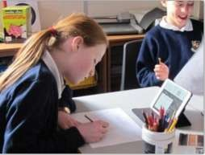
About our School
The original school building was built in 1871 but many modern additions allow access to all areas: 7 classrooms, nursery classroom and outside play area, a large hall, allotment and growing garden, playing /sports field, forest area, library, computer suite, cooking resource room and many more small rooms for varied activities and lesson support.

Organisation
Children are entitled to spend up to five terms in the Nursery, accessing morning or afternoon sessions (mornings: 8.45-11.45, afternoons: 12.30-3.30pm) from the start of the term after their third birthday.
Children spend seven years at primary school.

Age | Class | Stage
3-4 years | Nursery (Potter Class) | FOUNDATION STAGE
4-5 years | Reception (Hubble Class)
5-6 years | Year 1 (Edison Class) | KEY STAGE 1
6-7 years | Year 2 (Byron Class)
7-8 years | Year 3 (Darwin Class) | KEY STAGE 2
8-9 years | Year 4 (Anning Class)
9-10 years | Year 5 (Newton Class)
10-11 years | Year 6 (Turing Class)

Curriculum
At St John's school we follow a thematic approach to the curriculum. We can see the benefits for all children in making connections between different areas of learning. At Foundation stage (nursery and reception classes) the teachers follow a programme of work planned from the Foundation Stage Curriculum which incorporates seven areas of learning.

In KS1 (Edison Year 1 and Byron Year 2) and KS2 (Darwin Year 3, Anning Year 4, Newton Year 5 and Turing Year 6) work is planned in five blocks and follows the guidance as laid out in the national curriculum. The children will have their own learning diary in which the majority of their work will be recorded. Key Stage 1 and lower Key Stage 2 use the Read, Write Inc phonics/reading scheme.

We feel it is important that children develop a sense of pride in their work and are able to revisit themes so that they can re-evaluate it themselves.

As a Church of England school we follow the Religious education scheme as provided by the diocese.

We recognise that our young people need to grow in both knowledge and understanding of the Christian religion and other world religions. We also aim to develop spirituality in our pupils through recognising the awe and wonder of the world around us.

We also fit in brass instrument classes, eco, gardening and cooking activities on a rotation basis for classes. Also, swimming, hockey and a variety of sporting activities at Kingston College or the Territorial Army Centre. Throughout the year, themed days /weeks are woven into the curriculum to extend the breadth and balance of opportunities we offer our pupils. These include: Anti-bullying Week, Internet

Safety Day, World Book Day, Black History Month and a week devoted to a curriculum subject. For example, Science week.
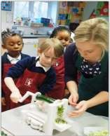
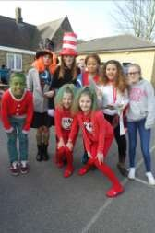
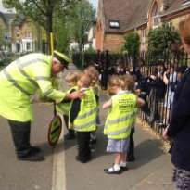

The School Day
The playground will be open each morning from 8.45am and children will be encouraged to go straight into their classrooms.

School Open: 8.45am
Registration: 8.55am
Break 10.25-10.40 am
Yr R and KS1 Lunch: 12 noon-1.00pm KS2 Lunch: 12.10-1.10pm
Afternoon break: 2.10-2.20pm School finishes: 3.20pm

Nursery am: 8.45-11.45am Nursery pm: 12.30-3.30pm

Collective Worship Times

10am Monday 9.05am Tuesday KS2
10am Tuesday R and KS1 10am Wednesday
10am Thursday 9.05am Friday

Joining the School

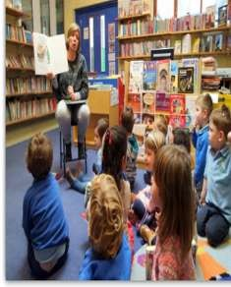
Starting school is a very important time for you, your child and the school. We all need to work together to make the transition smooth and rewarding.
In the term prior to their entry, pupils are invited into school for visits. This will help them become familiar with the surroundings and routines of school. During this period, there will be meetings for parents to discuss our partnership with you and talk about any concerns you might have.

Pupils will be admitted into the Reception at St John’s C of E School in the September of the academic year in which they are five. The Early Years Curriculum is grounded in active learning. Through practical activities, purposeful play and talk, pupils develop an understanding of the world and the basic concepts theywillneedfortheirlaterlearning.Parentscanplayamajorroleinfosteringgoodattitudestolearning, developing language skills and promoting good behaviour. Every child deserves the best possible start in life and the support that enables them to fulfill their potential. Children develop quickly in the early years andachild’sexperiencesbetweenbirthandagefivehaveamajorimpactontheirfuturelifechances.
A secure, safe and happy childhood is important in its own right. Good parenting and high quality early learning together provide the foundation children need to make the most of their abilities and talents as they grow up. The Early Years Foundation Stage (EYFS) sets the standards that all Early Years’ providers must meet to ensure that children learn and develop well and are kept healthy and safe. It promotes teaching and learning to ensure children’s ‘school readiness’ and gives children the broad range of knowledge and skills that provide the right foundation for good future progress through school and life.

Admission Arrangements
Please see the school website http://www.stjohns.kingston.sch.uk/admissionsfor Admissions Policies and supplementary forms:

Admissions Policy

Pupil Application Supplementary Form
Clergy Supplementary Form (if applicable)

Borough Entry to Schools Application &Information
The two forms are supplementary forms that need to be returned to the school whereas the Borough Common Application Entry to Schools form is obtained from Kingston Borough and should be returned directly to them. www.eadmissions.org.uk

Please call our school if you would like further help.

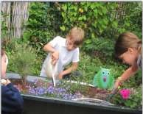
Inclusion and Equality
At St John’s we are committed to ensuring equality of education and opportunity for all pupils, staff, parents and carers receiving services from the school, irrespective of race, gender, disability, faith or religion or socioeconomic background. We aim to develop a culture of inclusion and diversity in which all those connected to the school feel proud of their identity and able to participate fully in school life.

Safeguarding
The safety and well-being of every child and member of staff at St John’s is of paramount importance to us. We are committed to safeguarding and promoting the welfare of children (both off-line and on-line) and share this commitment in line with the new government document, Keeping Children Safe in Education September 2016. All staff work hard to maintain an environment where children feel safe and secure and the curriculum is designed to ensure opportunities for children to develop the skills they need. Children know that they can approach any of the adults in school if they are worried and that they will receive a consistent supportive response.

Parents in Partnership
We welcome parents and carers into St John’s believing we are partners in the education of your children. There are many opportunities for parents to become involved in the life of the school and to gain a greater understanding of its work. Parents’ support and expertise can be used in many ways and is greatly valued. Police checks and DBS checks are carried out on all adults working in school including regular volunteers. If you are able to help, please talk to your child’s teacher.
We communicate with parents and carers in various ways, for example through our weekly newsletters, questionnaires, workshops and informal social events. Parents are regularly invited to assemblies, and to Parents’ Evenings. Every year parents and others are invited to Sports Day as well as children’s performances. Staff will always be happy to meet with parents and carers to share any concerns. The school has a Home School Agreement to support the partnership between home and school, and foster shared dialogue. The School’s website has a wealth of information including our weekly newsletters, class pages and copies of key policies.

Parent Staff Association
The PSA exists to support the life and work of the School and is open to all members of the school community. The Association provides invaluable support to the school through organising many social and fundraising events involving parents and the wider local community. Money raised provides extra facilities and equipment for the pupils. The group holds regular meetings in school, with dates and details published in the ‘St John’s News’, our school’s newsletter. The PSA identifies long and short-term projects for its fundraising; this enables us to buy ‘special’ extras to enhance pupils’ school experience. The PSA needs the support of parents to

ensure it is able to continue to enrich the lives of children. As a new member of our school community we hope you will be able to add your support to the work of the Association.

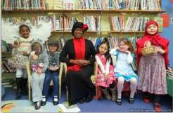
Additional Information

At St John’s we promote a caring and stimulating environment for all our children. Our belief is that pastoral care stems from positive relationships between children, staff and parents.
The class teacher is accountable for the care of the children in her/his control with the Headteacher having overall responsibility for all the children’s welfare.

Parents are consulted regularly and a home school agreement is signed which sets clear objectives for the school, the parents and the children.
The school is also in constant liaison with personnel from outside welfare agencies including:

- The SchoolNurse
- The Education WelfareOfficer
- The EducationalPsychologist

Positive behaviour through praise, encouragement and a system of pupil generated rules promotes respect for oneself and for others.
Our behaviour Management Policy makes specific reference to rewards and any necessary sanctions made in the best interest of all our children.
In addition strict policies on equal opportunities, personal, social, health and moral education and an anti- bullying code provide a safe and non-judgmental environment in which children can readily express their feelings.
OFSTED quote: ‘Pupils’ personal development and well-being are outstanding’

Home/School Agreement
We believe that a positive and supportive relationship between home and school is a vital factor in the happiness and development of children. The governors and staff have therefore drawn up an agreement in line with Government legislation to be signed by all parents of children entering the reception class. We hope this agreement will foster a genuine and fruitful partnership between parent, teacher and pupil.
Copies are available in the School Office.

School Medication Service and the Role of the School Nurse
The School Nurse visits the school each term. Part of her work is health promotion. The following are offered for which parents’ written consent is obtained:
- hearing test at school entry, with further monitoring if necessary
- selective check-up by the School Nurse during the year after the fifth birthday, and continued monitoring, if necessary
- Height and weight measuring during their time at StJohn’s
Please note that this programme can alter according to priorities set out by the Health Authority.
Parents are asked to check their children’s hair regularly for head lice, and advice is provided by the school when necessary.

Medicines in School

The LA and the School Nurse have set guidelines for the use of medicine in schools, and these are available from the School Office.

Homework
Homework is viewed as a positive link between home and school at St John’s. It starts in Reception Class with a range of basic confidence building tasks and nightly reading preparing the children for the more formal homework in Year 1. Years 1 to 6 receive homework in accordance with our agreed Homework Policy.
Additional work to reinforce and extend pupils will also be set where appropriate. The School’s homework guidelines are available in the School Office.

Charging (and Remissions) Policy
The Governing Body has adopted the LA’s standard charging and remissions policy, details of which are available from the School Office. The Education Act 1988 requires that some visits and activities are funded on a voluntary basis only. No child will be excluded. Parents should realise that if insufficient contributions are received, the activity may be cancelled. Children involved in making practical items at school (baking, sewing, art and pottery) are not generally charged for such items however sometimes parents are requested to contribute ingredients or a small financial cost. The Governors expect parents of any child whose behaviour results in damage, breakage or loss of school property to pay all costs thereby incurred.

Access to Documents
All documents which parents have a statutory right to view are available in the School Office and are on the school website.
- Policy on PSHE and SexEducation
- Policy on Charges andRemissions
- Policy on ChildProtection
- Complaints Procedure
- Kingston Borough Curriculum Policy and LA policy statements
- All DFE documents relating to the curriculum
- All schemes of work followed by pupils at the school

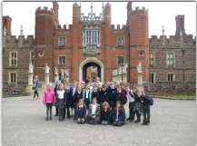

Absence
If your child is unable to attend school or nursery for any reason, please telephone or e-mail the school office to let us know. If your child has sickness or diarrhoea we ask that he/she does not return to school for 48 hours as this type of illness can be very infectious. To encourage high levels of attendance, we award attendance certificates to classes who achieve 100% attendance in any week.

Punctuality
The school day begins promptly at 8.55am, but we ask that children arrive at 8.45am and proceed promptly to their class to ensure a positive start to their learning. Please make sure your child is not late for school.

Children who arrive late are asked to report to the school office on arrival. Any late attendance is recorded on the end of year school report to parents.

Holidays during Term Time
From 1 September 2013, the DfE regulations have come into force regarding leave of absence for children from school. The current law does not give any entitlement to parents to take their child on holiday during term time. Any application for leave must be in exceptional circumstances and the Headteacher must be satisfied that the circumstances warrant the granting of leave.

Times of the School Day
The gate opens at 8.45am and we expect all children to go straight in to their classrooms for a prompt start to the school day by 8.55 am at the latest when the register will be taken. Apart from children in upper Key Stage 2, pupils (with permission from their parents) should not arrive unaccompanied. Football and other games are not allowed before and after school because of younger children and adults’ presence on the playground at these times. Playground apparatus are also out of bound at these times.

Community Links
St John's school has strong links with the local churches of St John's, All Saints and Kingston Methodist Church. Church ministers regularly attend and lead assemblies and we attend St John's Church for important celebrations such as All Saints Day, Harvest Festival and Ash Wednesday. Members of these churches form an important part of our governing body. We also are privileged to make very good curriculum links with The Rose Theatre, Stanley Picker Gallery, Museum and Library, Kingston College and the TA Centre.

School Council
The School Council was set up to enable our children here at St John's to have a say in the running of their own school. In this way, our children have a greater sense of belonging, become more confident when putting forward ideas and develop a greater understanding of the need to work co-operatively for the good of others.

Our School Council is made up from elected representatives from each class. In July, we hold elections for the new school councillors. Firstly, the children are nominated; next they have to prepare a manifesto and give a speech to their class. Finally all of the children vote for the people they think would make a good school representative. Each class is represented by two elected members.

Lost Property
Naming all items reduces the risk! Any items of lost property are put in a central ‘Lost Property Bin’ in the school office - if your child has lost something then please check there. We do keep lost property for a reasonable period of time; but it is often difficult to identify items that are not named. Displays of lost property are made at the end of each term.

Road Safety Education
As part of our School Travel Plan, developed in conjunction with the Local Authority, children are encouraged to walk or cycle to school. Cycle shelters and a scooter racks are available at school for bicycles and scooters to be left during the school day. During the spring/summer term, Year 5 children are offered ‘Bikeability’ training run by the local authority. Parents are asked not to use the school car park - thank you.

Clubs
There are many clubs at St John’s including: BMM Sports (Football & Hockey), Chess, Drama, Spanish, Skipping, Netball, Gardening, Choir, Lego, Dance, Gymnastics, Karate, Art, Sewing & Crafts, Early Maths, and Maypole/Country Dancing.

Eco School & Healthy Eating
We are an accredited Eco School and our Eco Mission is: Through our learning, we believe in caring for, protecting and sharing our environment with plants, animals and each other. We actively encourage recycling, reusing and limiting use of energy and resources. We have National Healthy School Status, the Green Flag Eco Award and were Green Guardian winners. We are committed to promoting and monitoring healthy food at break and lunch times. Different teaching styles and learning opportunities are offered to pupils to develop their awareness and understanding of healthier eating and basic food safety practices, including opportunities to grow and cook vegetables.

Sports
In the past, we have worked with a wide range of sports specialists within the school. This academic year we have an excellent dance coach working with year groups. This coach runs the dance training sessions for Kingston and other boroughs, as well as being a dance coach who has prepared the celebrities for Strictly Come Dancing.

School Meals
Our school meals provider is ISS Facility Services. The link to their website is www.feedinghungryminds.co.uk

DISCLAIMER
The school has tried to provide fully up-to date information as required by law. Regulations are continually changing but we will do our best to keep parents informed of the alterations.

We do hope that you have found the information contained in this pack valuable and interesting. If you have any further questions please feel free to ask.

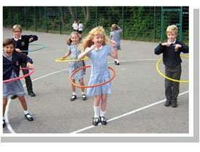
Term Dates for Academic Year 2019 to 2020

Autumn term 2019
- Wednesday 4 September 2019 to Friday 25 October 2019
- Monday 4 November 2019 to Friday 20 December 2019

Spring term 2020
- Monday 6 January 2020 to Friday 14 February 2020
- Monday 24 February 2020 to Friday 3 April 2020

Summer term 2020
- Monday 20 April 2020 to Friday 22 May 2020 (including bank holiday on 4 May)
- Monday 1 June 2020 to Wednesday 22 July 2020

List of Governors

Mrs L Charlton Foundation Governor, Chair
Ms A Warren Parent Vice Governor
Foundation Governor
Mrs L Esua Headteacher
Mrs K Kwateng Foundation Governor
Vicar of St John’s Church Not currently filled
Mr F Land Parent Governor
Ms E Sanchez Parent Governor,Treasurer
Mrs E Briten LA Governor
Mr G Limna Parent Governor
Mrs C Singh Associate
Mrs S Constable Teaching Governor
Dr Karl Rutlidge Foundation Governor

School Governors may be contacted through the School Office - Mrs Libby Lazenby is Clerk to the Governors.

The School Staff
Teaching & Classroom Staff

Mrs L Esua Headteacher
Mrs C Singh Deputy Headteacher
Mr G Redhead Turing Class6 (English & KS2 Senior Leader)
Miss K Johnson Newton Class 5(Maternity leave)
Mr J Smith Newton Class 5 (Supply cover)
Mrs C Campbell Anning Class4 (Maths Leader)
Miss N Wilson Darwin Class3 (PE Leader)
Ms Brierley Byron Class2 (Science & KS1 Senior Leader)
Mrs H Keaney Edison Class1 (Humanities Leader)
Mrs S Constable Hubble Reception Class R (Art & Design, DT Leader
Mrs A Hutchinson Potter Nursery Class (SEND and EYs Leader)
Ms E Jaquest Potter Nursery Class (EAL Leader)
Mrs J Green Higher Level Teaching Assistant (Computing Leader)
Mrs L Hunter Teaching Assistant (PSHE Leader)
Mrs S Ben Serghin Teaching Assistant
Mrs D Cole Teaching Assistant
Mrs C Palmer Hall Teaching Assistant
Mrs M Katushabe Teaching Assistant Mrs M Ellahi Teaching Assistant
Miss L Fenn Teaching Assistant
Mrs H Mutch Nursery Nurse
Mrs K Edwards Nursery Nurse

Non-Teaching Staff

Mrs N Rees School Business Manager Miss S Sharma Clerical Assistant
Miss L Schembri Apprentice
Mr P Hemmings Site Manager
Mrs T Lindsay Lunchtime Supervisor Mrs L Parison Lunchtime Supervisor

A list of areas of responsibility and photographs are in the school entrance.

After School Club Staff

Mrs S Turner Miss S Cruise
Mr A Cole
Mr E Cole
Miss Kingdon
Miss S Ashley

Attendance
Latest Incidence of Unauthorised Absence (as percentage of possible attendance)
Number of pupils of compulsory school age on roll. 205
This excludes children in Nursery class

Percentage of half days (sessions) missed through authorized absence 2.95% Percentage of half days (sessions) missed through unauthorised absence 0.91%

The school carefully monitors all absences and although our percentage of unauthorised absences across the whole school is extremely low (absences where a letter, email, phone call or reason has not been provided); in most cases this is caused by a very small group of parents who often forget to contact the School Office.

School Results
St John’s Church of England
Two Year End of Key Stage Data Overview 2018-2019

Foundation Stage
 | Good level of development
% | 2017/18 | 2018/19
School | 90 | 80
National average | 72 | 72
Phonics Screening
Y1 Phonics screening%
 | 2017/18 | 2018/19
School | 83 | 83
N.A. | 83 | 82

KS1 Reading SATS Results (Y2) %
Grade | 2017/18 | N/A | 2018/19 | N/A
Exp | 83 | 75 | 82

KS1 Writing SATS Results (Y2) %
Grade | 2017/18 | N/A | 2018/19 | N/A
Exp | 79 | 70 | 82

KS1 Maths SATS Results (Y2)
Grade | 2017/18 | N/A | 2018/19 | N/A
Exp | 83 | 75 | 82

Y6 SATS Results
Standards | Reading % |  |  | Writing % |  |  | Maths % |  |  | GSP %
Year 2017 -19 | 17/18 | 18/19 |  | 17/18 | 18/19 |  | 17/18 | 18/19 |  | 17/18 | 18/19
School % | 96 | 93 |  | 84 | 97 |  | 100 | 97 |  | 92 | 100
School GD | 48 | 33 |  | 19 | 33 |  | 30 | 57 |  | 48 | 47
National % | 75 | 73 |  | 78 | 78 |  | 75 | 79 |  | 78 | 78

KS2 SATS Combined Reading/Writing/Maths Expected Standard (Y6)
 | 2017/18 | 2018/19
School | 78% | 90%
National average | 64% | 65

Key
Expected – Exp, Expected plus - Exp+, Greater Depth – GD, National Average – N/A, Teacher Assessment – TA

