Pre-fixes 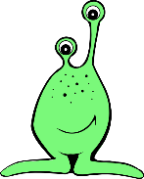
I can add un to change the meaning of an adjective or verb.
Rewrite the sentences and add un to the adjective or verb. You can choose the sentences you want to write and how many or think of your own!

Aliens are lucky to live in space.

The alien is tidy.

The aliens are happy.

My alien is feeling well.

My alien is kind.

