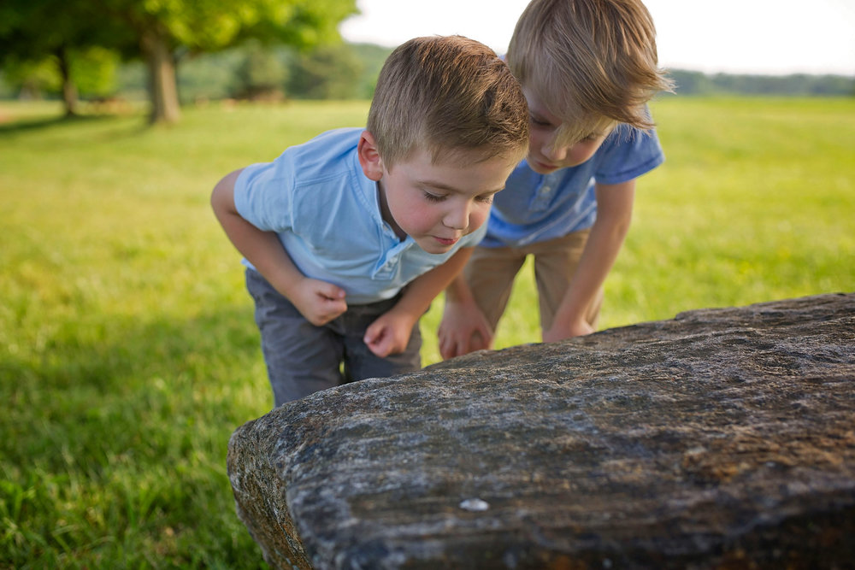  Speech! Still an issue, but getting better. Here is my reminder of the 4 ways:  - “What on Earth is that?” gasped Harold.  - Harold looked at Bob and whispered, “I’ve never seen anything like it.”  - “I think it moved!” shouted Bob. “It’s alive!”  - “I’m going to eat it,” said Harold, ”because I’m still hungry after our picnic.”  Do you remember the difference between 3 & 4?  Plan first!  Things to consider:  What on Earth is the thing?  Does the reader ever actually need to know what it is, or are you going to leave them guessing?  Why are the two characters there?  Is it going to be dangerous?  Is the thing alive?  How is the story going to end?  Write a decent paragraph each day, and edit it carefully. Use the document I have created for you in google classroom.  Start each day by re reading what you wrote the day before. | Tell me a story 6 - What on Earth is that?  Your task is to write a short story based on this scenario. It will involve a great deal of rich description, and 2 characters. The trick to descriptions is to consider the different senses. What can you: see, hear, smell, touch or even taste?  A new issue has developed. The issue of comma splicing. I am seeing too many.  A comma splice occurs when you try to join two clauses with a comma without using a conjunction, and without it being a fronted adverbial. Here is one now:  Jane was horrified, the bug she had just squashed was dancing the tango.  UrrGh!!! That is a comma splice. Isn’t it horrible?  This should have been either a full stop or a semicolon. Alternatively you could add a conjunction such as ‘because’.  Don’t forget. Show off!  You should always include modal verbs, clause dashes and passive voice, but how about parenthesis? Adding extra information with brackets, dashes or commas. Like this:  Harold, who felt particularly hungry, reached for the strange thing.  Harold - who felt particularly hungry - reached for the strange thing.  In these examples the parenthetic clause is also a relative clause - starting with the relative pronoun ‘who’. This is also a good thing.

