Home learning WEEK 1
Edison Year 1
Weekly Maths activities | Weekly Reading activities
- Use www.topmarks.co.uk to play different maths games. For example  Hit the button- number bonds (start with up to 10- make 10) and doubles (start with doubles to 10). Helicopter Rescue (Find a number/ count on and back) and Coconut odd and even (start with 1-20).  Mathletics- use your Mathletics login  Practise counting in 2s, 5s and 10s. Remember our counting in 2s, 5s and 10s hands.  Start at different numbers and use your 100 square.  Colour the numbers on your 100 square to show the numbers you say when you’re counting in 2s 5s and 10s.  - Practise telling the time. We have been learning o’clock in class and have talked about hours, minutes and seconds. Talk about half past the hour. The children can draw hands on a clock face to show these times.  - Write the numbers 0-20 in words and digits. | - Read a variety of books at home.  - Read a book (or a couple of pages of your book) every day and share a book with an adult.  - Oxford Owl – use my class login. My Book shelf. Click on a book. Listen to the story and play activity 1/ 2.  - Listen to a story on Storytime.
Weekly Phonics/Spellings  activities | Weekly Writing activities- The UK
- Do phonics every day- use the phonic sheets I sent home with you to practise reading new words. Remember to do your sound buttons and underline special friends. Don’t forget to give yourselves a ‘rainbow clap’ and a ‘hip, hip hooray’!  - Use these Interactive games found on the links below.  - Phonics play  - Top Marks  - Spelling  https://www.teachyourmonstertoread.com/ | - The next country we are learning about in the UK is Northern Ireland. Find out a few facts about Northern Ireland. For example, what is the capital of Northern Ireland, what is the Giant’s Causeway? Watch a clip of Irish dancing. I have included a PP for you to talk about. Then write a couple of sentences about Northern Ireland and draw a picture.  - Remember to use your sound mat and Tricky word mat- Don’t forget those capital letters, full stops, finger spaces and adjectives.  - Lots of you have enjoyed writing your own stories. Have a go at writing your own story at home. You could fold a sheet of A4 paper into 4 to make a little book. You could do a front cover and then read your story to your family.
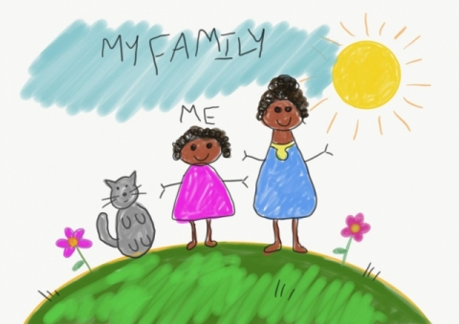
RE
In RE we have been learning about the Easter story. We have been learning about Holy Week and what happened on Palm Sunday, Maundy Thursday and Good Friday. Watch ‘The Beginner,s Bible- The Easter story’ on You tube. We have seen up to Good Friday. If you have a children’s Bible then please read the Easter story to your child. Talk to your child about what happened on the first Easter Sunday. Ask them to write about what happened and draw a picture.

Art

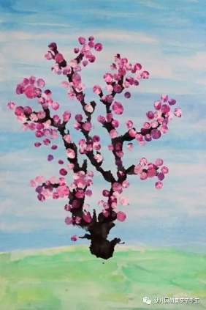

Japanese Cherry blossom trees- use google to find pictures.
Have a go at drawing, painting (finger painting) or collaging your own Japanese cherry blossom tree. Ask if you can put it up on your bedroom wall or in a special folder - we are going to start our own gallery of lovely pictures.

Science
Click on the Padlet link below to write about what pet you would like to have and what animal group it belongs to. Remember how to add a picture- click on the magnifying glass icon and change the search to what you want. Then click on your chosen photo to add it to your text box. I look forward to finding out about all the pets you would like! Remember no names- use your number.

https://padlet.com/hkeane61/uh9hn1x08qh8

Go outside if you can to play and get lots of lovely fresh air.
Take care and enjoy doing your home learning! Love Mrs Keaney

