How Does David’s Faith Show The Strongest Strength?
Read the story David and Goliath

You could also listen to this audio version

How was David put down by others in the story?
This Photo by Unknown Author is licensed under CC BY-SA
How did he overcome others’ lack of faith in him?
What helped him to do this?
What do you think Christians find inspiring about the story of David and Goliath? Why?

Activity:
This Photo by Unknown Author is licensed under CC BY-SA
What do you find inspiring about the story of David and Goliath?
Make your own piece of art to show the message that the story teaches.
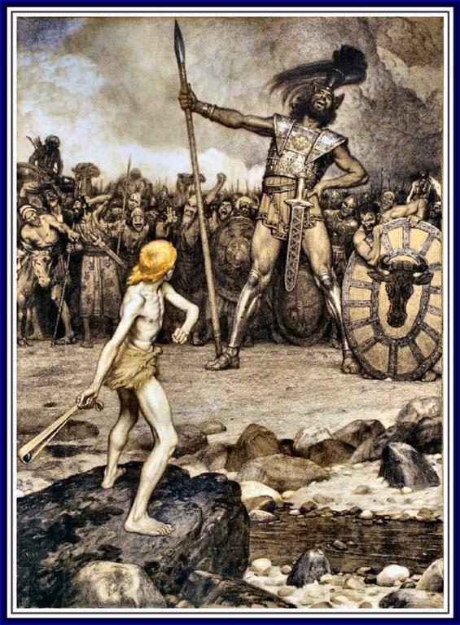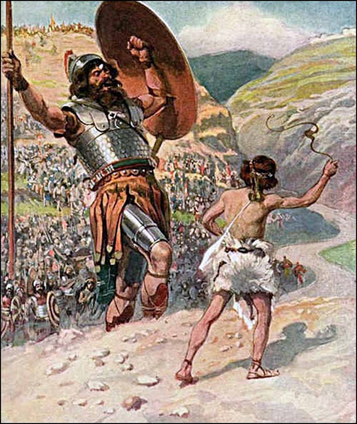

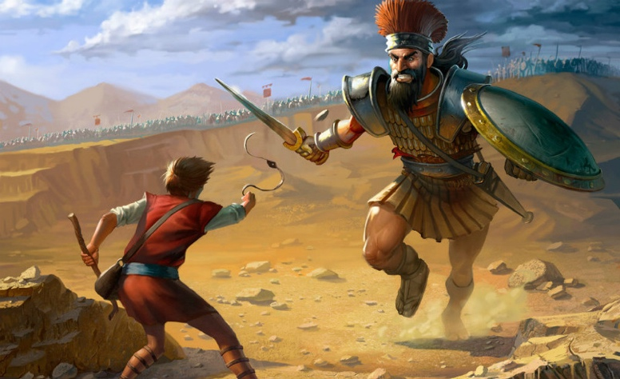
These are some examples of art images of David.
How is David shown?
What do you think the artist is trying to show?

