Learning Project WEEK 4- 29.06.2020
Age Range: Y4
Daily Maths Lessons | Weekly Reading Tasks (Aim to do 1 per day)
- For Mental Maths and Times Tables : Choose one of following resources and do one each day for 5 - 10 mins before main maths activity  - Working on Multiplication Check on Maths Frame https://mathsframe.co.uk/en/resources/resource/477/Multiplication  - Top Marks - Daily Ten https://www.topmarks.co.uk/maths-games/daily10  - Play on Hit the Button - focus on times tables Hit the answer/ Hit the Question  - Mathletics - Times tables Practise  - Everyone should be following White Rose Online Maths Tutorials Summer Term  - Week Monday 29th June topic : Charts and Graphs  https://whiterosemaths.com/homelearning/year-4/ | - You could share a story together. This could be a chapter book where you read and discuss a chapter a day.  - Listen to your child read and let them discuss what they have read. Encourage them to read with expression and intonation.  - Watch Newsround and discuss what is happening in the wider world.  - Get your child to read a book on Oxford Owl, discuss what your child enjoyed about the book.  - Explore new vocabulary you find when reading. What are the origins of this word? Can it be modified? Can you find any synonyms or antonyms for your new word?  Tom Palmer - This is a Youtube link for  author of the book The Character Strikes Back if you want to listen to more of his amazing stories:  https://www.youtube.com/c/TomPalmerAuthor/videos
Weekly Spelling | English Lessons
Please Note we have now completed all the Year 4 Spellings - I would encourage you to revise all these Spellings but for this week please become familiar with these words below and learn how to spell them:  Monday- Resilience talk about the meaning and practise spelling it.  Tuesday- Responsibility talk about the meaning and practise spelling  Wednesday- Patience talk about the meaning and practise spelling it  Thursday- Tenacious talk about the meaning and practise spelling it  Friday- Courage talk about the meaning and practise spelling it | - Monday 29th June Lesson 1  - Watch Dr.Seuss Video on Youtube  https://www.youtube.com/watch?v=i-hW8KOdqnQ Then watch online tutorial  Do Activity 1 - What Could it mean?  - Tuesday 30th June Lesson 2  - In the Places You’ll Go! tells the story of a journey. This journey represents the Traveller’s life. Make a list of the places the Traveller visits and the things that happen along the way – his life story. Draw a timeline and mark the places and events on it. Can you find a way of showing how the Traveller feels about these places and events?  - Wednesday 1st July Lesson 3  See Online Tutorial- Follow-up Activity The Problem  - Thursday 2nd Lesson 4  - What are your hopes for the future? Think about what you’d like to do, where you’d like to go and the things you’d like to achieve. What skills, behaviours or attitudes will you need to make these things happen? For example, you might need to be hardworking, open-minded  - Follow-up - Oh the Places You’ll Go sheet  - Friday 3rd July Lesson 5  - “So be sure when you step. Step with care and great tact and remember that Life’s a Great Balancing Act…” What do you think this quotation means? Could it help you in real life? How? Many people like to remember quotations that offer good advice – and there are plenty to choose from in this book. Find passages that would make good quotations for this purpose. Which is your favourite, and why? Write your chosen quotation in Words to Keep With Me
Foundation Subjects - to be done throughout the week

Art
You can draw an Ancient Greek vase. I uploaded some pictures during the week of Ancient Greek pottery. If you have already done this then you can do an Ancient Greek Mosaic of a vase or see the examples I have attached. This is very easy to do with any spare paper , coloured paper if you have it or you can cut from an old catalogue.

- Topic: Ancient Greece
Women in Ancient Greece - What was life really like ? Use Power Point attached.
What do these pictures tell us about the role of women in Ancient Greek society?
What sources of evidence are provided in the Powerpoint to tell us about the life of women in Ancient Greece ? Write a short paragraph describing what you think life was like for women in Ancient Greece. Draw some pictures of women from Ancient Greece times.

- Be Active:

Remember the Joe Wicks morning workouts start at 9.30am. This is a
fantastic way to start your day. Other things that you can do are go on a bike ride, go for a nice walk or do some skipping.

Recommendation at least 2 hours of exercise a week.

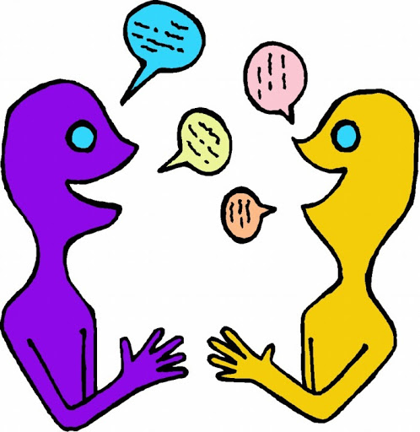
- Time to Talk:
Challenges and changes can scare us, even when we welcome them. It’s possible to feel scared and excited at the same time! In the Dr Seuss story he has shown the Traveller meeting some scary rock-like creatures with green eyes. “And when you’re alone, there’s a very good chance you’ll meet things that scare you right out of your pants. There are some down the road between hither and yon That can scare you so much you won’t want to go on…” Imagine you’re walking along the path in this picture with the Traveller. What can you see, hear and smell? How do you feel? What does the Traveller say, and how do you respond? What happens as you pass the rock-creatures? Tell the story. What frightens you? How does being frightened make you behave? What attitudes and actions help you deal with your fear and keep going? Use plasticine (or similar) to make rock-creatures like the ones in the story.
Additional learning resources parents may wish to engage with
Classroom Secrets Learning Packs - These packs are split into different year groups and include activities linked to reading, writing, maths and practical ideas you can do around the home.
Twinkl - to access these resources click on the link and sign up using your own email address and creating your own password. Use the offer code UKTWINKLHELPS.
Headteacherchat - This is a blog that has links to various learning platforms. Lots of these are free to access.
#TheLearningProjects

