The Lighthouse Keeper’s lunch 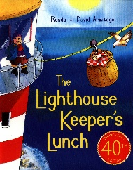
Draw a picture of Mr and Mrs Grinling’s cottage. | Describe the cottage. Where is it? What would you see if you looked out of the window? What would you hear?
Draw a picture of where Mr Grinling works. | Describe the lighthouse and where it is.

