Emotion Wheel

Emotion Wheel

Before you begin, spend a few minutes thinking about the different emotions.
- What do they mean to you?
- How does it feel? Do you enjoy the feeling?
- Can you link a colour to an emotion eg red for Anger?
- Think about when you experience these emotions

Now look at the Emotion Wheel.

In each segment fill in what that emotion means to you.

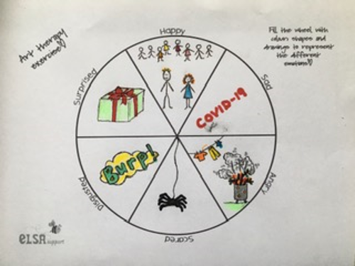
You can Draw, Write, Colour, use pencil, felt tip to create an Emotion Wheel of your own.

When you have finished, share it with a parent, carer or older sibling. What do they think?

Here is my Emotion Wheel.

I hope you enjoy doing this.

Miss Palmer-Hall

copyright ©ELSA Support

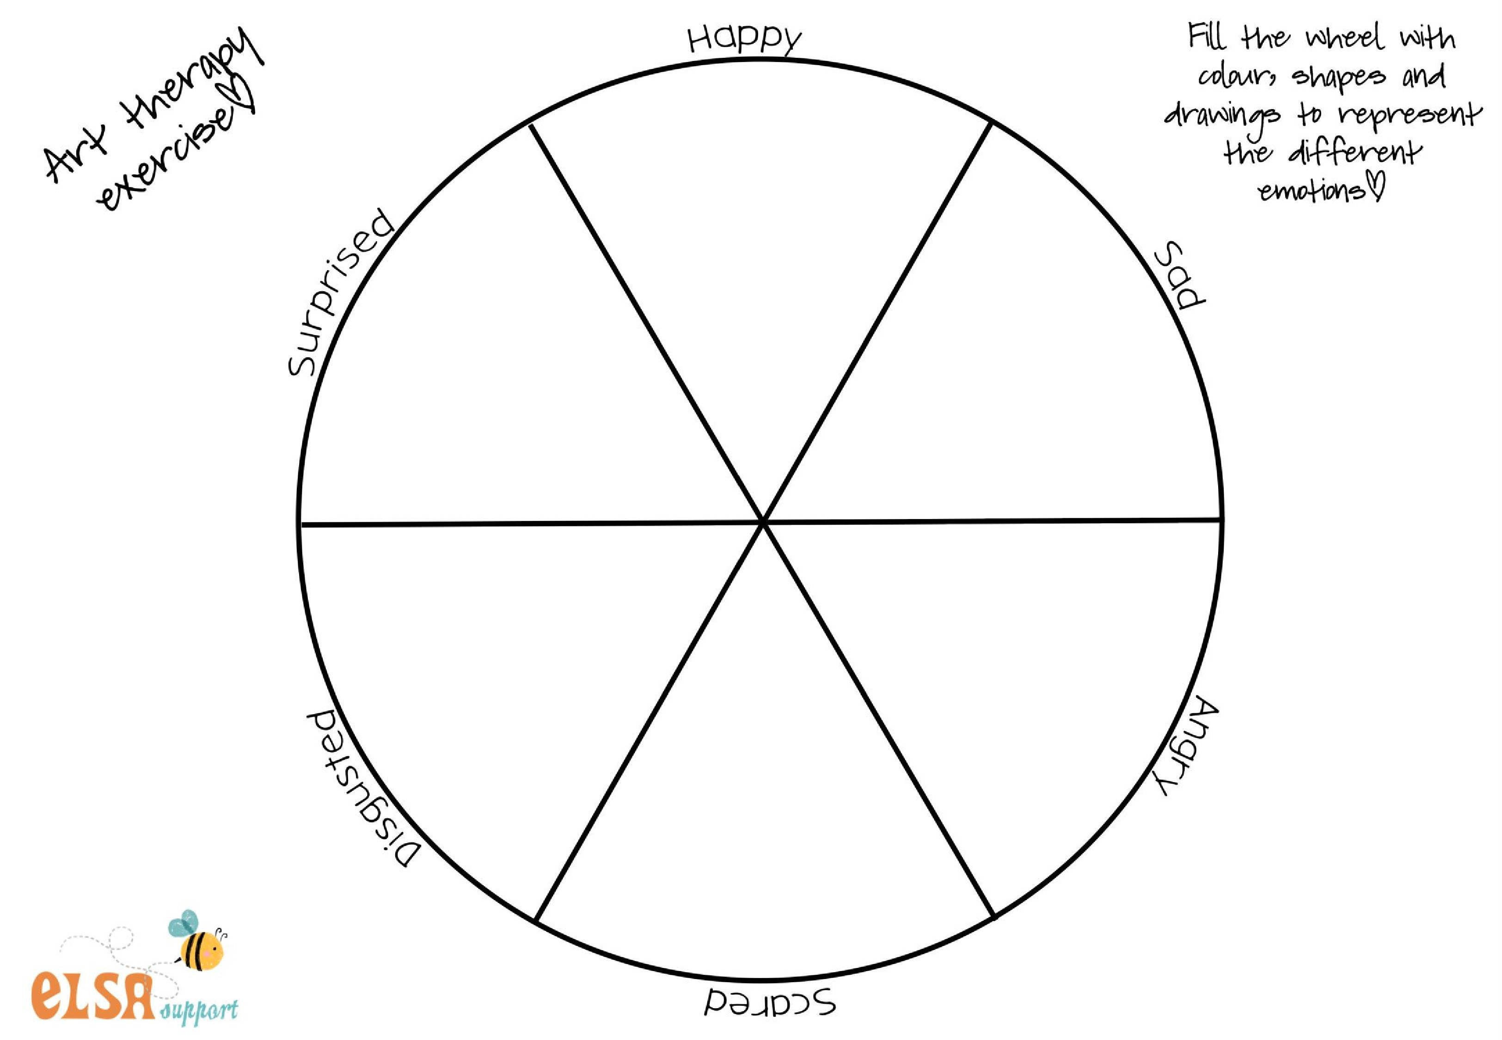
copyright ©ELSA Support

