Home Learning
WEEK 4
Y2
Weekly Maths Tasks | Weekly Reading Tasks
- Play on Number Fact Families - find the addition and subtraction fact families for numbers up to 20, 50 or 100.  - Practise counting in 2s, 5s and 10s. This game could support this.  - Practise learning about money by playing this game. You could also use real coins and play a similar game with family members.  - Select a number between 2 and 20. Make a poster showing how many different ways to make this number using addition, subtraction, multiplication etc.  - Ideas for home learning from the Oak National Academy:  https://www.thenational.academy/online-classroom/year-2/#subjects | - Can you read fiction, non- fiction and poems about flowers/plants/trees?  - Can you find adjectives in the books used to describe the plants?  - Create a bookmark with plant facts.  - Read common exception words and time how long it takes for you to read them all. Can you beat your score by the end of the week? (common exception words are on the class page too)  - Share the ‘Katie’ books by James Mayhew online. Use the Katie  notes to unlock a wealth of ideas to share at home.  https://www.youtube.com/watch?v=UvczDIo0Bhw  #storytime4hometimewithjamesmayhew
Weekly Phonics/Spellings  Tasks | Weekly Writing Tasks
- Phonics play  - Top Marks  - Spelling  - Spelling City | - A-Z flower/plant/tree list: Can you think of a flower/plant for each letter of the alphabet?  - Draw a picture of your plant and label it. Can you write sentences using adjectives?  - Write a set of questions about flowers/plants you would like to find out about.  - Create a fact file about your favourite flower. Research a plant/flower of your choice and explore the vocabulary required to describe them.  - Describe similarities and differences between flowers/plants.
Learning Project
The Association of Science has an excellent materials project children may want to do.

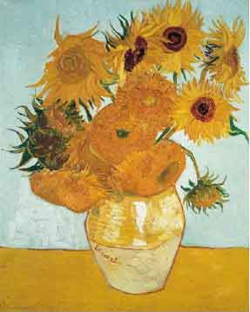

Art What do you know about Van Gogh’s
Sunflowers? Draw, paint, make/plant your own!

DT learn to design, make and evaluate a bathing machine.
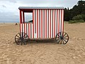

Additional learning resources parents may wish to engage with:
Twinkl - to access these resources click on the link and sign up using your own email address and creating your own password. Use the offer code UKTWINKLHELPS.

https://www.bbc.co.uk/bitesize/topics/z6882hv

