Learning Project WEEK 3- 15.06.2020
Age Range: Y4
Daily Maths Lessons | Weekly Reading Tasks (Aim to do 1 per day)
- For Mental Maths and Times Tables : Choose one of following resources and do one each day for 5 - 10 mins before main maths activity  - Working on Multiplication Check on Maths Frame https://mathsframe.co.uk/en/resources/resource/477/Multiplication  - Top Marks - Daily Ten https://www.topmarks.co.uk/maths-games/daily10  - Play on Hit the Button - focus on times tables Hit the answer/ Hit the Question  - Mathletics - Times tables Practise  - Everyone should be following White Rose Online Maths Tutorials Summer Term  - Week Monday 15th June topic : Decimals  https://whiterosemaths.com/homelearning/year-4/ | - You could share a story together. This could be a chapter book where you read and discuss a chapter a day.  - Listen to your child read and let them discuss what they have read. Encourage them to read with expression and intonation.  - Watch Newsround and discuss what is happening in the wider world.  - Get your child to read a book on Oxford Owl, discuss what your child enjoyed about the book.  - Explore new vocabulary you find when reading. What are the origins of this word? Can it be modified? Can you find any synonyms or antonyms for your new word?  Myths and Legends : Fancy reading  some Ancient Myths and Legends you will find lots here :  http://myths.e2bn.org/mythsandlegends/
Weekly Spelling | English Lessons
Monday- Your child can learn to spell the continents of the world. Practise writing them using pencils, pens, chalk, sticks, typing, etc.  Tuesday- Practise spelling these words: Theseus,  Can your child identify the spelling rule for The /ɪ/ sound spelt y elsewhere than at the end of words (e.g. gym, myth... etc.)?  Wednesday- Can your child create their very own ‘Ancient Greek’ wordsearch? Help them write clues and a family member can complete it.  Thursday- Trace it. Choose 5 Common Exception words and trace around each word. What does your child notice about the shape of each word?  Friday- Write similes to describe a setting for a Greek Myth | - Monday 15th June Lesson 1  - Greek Myths  - Listen to Theseus and the Minotuar  https://www.bbc.co.uk/teach/school-radio/ks2-primary-history-ancient-greece-theseus/zkvqkmn  Make a list of vocabulary that describes the setting  - Tuesday 16th June Lesson 2  - Describing a setting for a Greek Myth  - See online tutorial  - Wednesday 17th June Lesson 3  Writing your plan on a Myth Map  See Attached Plan  - Thursday 18th and Friday 19th June Writing your own Greek Myth  See online Tutorial
Foundation Subjects - to be done throughout the week

Science/ Design Technology:
Last lesson in Sound - The Rockstar Challenge
Create a functional and appealing product that people can wear to protect their ears from loud sounds and noises. This product is aimed for people who have sensitive hearing, work with loud machinery or for those who are involved in the music industry, they could play in a band, rock group etc
Your Design should be made of materials which you think best muffles sound. Along with your design you should include a description. See attached Sheet for an idea.

- Topic:
- Go through the Powerpoint I’ve attached and think about when the Golden Age of Ancient Greece was. A simple timeline is provided on slide 9 which relates directly to the places introduced on slide 5 . Most of our attention in the topic will be focussed on the Golden Age of Athens in 6th and 5th century BC (before Christ was born) As you will see there were many different periods within Ancient Greece. These will become clearer as you refer back to the timeline . Also the role of war is a theme throughout this period.
- Task: You are going to take on the role of detectives trying to prove that the legend of Theseus and the Minotaur may actually have been a fact. What sort of evidence MIGHT have survived? Watch the clip of Theseus and Minotaur on Myths and Legends Website, So what might we find if we were archaeologists setting out to dig for evidence? Write them down and illustrate them also.

- Be Active:

Remember the Joe Wicks morning workouts start at 9.30am. This is a
fantastic way to start your day. Other things that you can do are go on a bike ride, go for a nice walk or do some skipping.

Recommendation at least 2 hours of exercise a week.

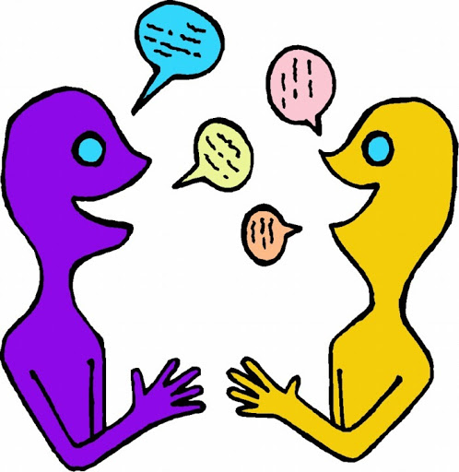
- Time to Talk:
https://www.bbc.co.uk/bitesize/clips/zqvnvcw -

Talk to your family about Racism. Discuss what has happened in the video. How does is make you feel? How do you think the girl in the clip felt? What can we do to help stop Racism ?

- Understanding Others and Appreciating Differences
- After watching the clip above think about creating your own poem about Racism. This could be written with illustrations.

Additional learning resources parents may wish to engage with
Classroom Secrets Learning Packs - These packs are split into different year groups and include activities linked to reading, writing, maths and practical ideas you can do around the home.
Twinkl - to access these resources click on the link and sign up using your own email address and creating your own password. Use the offer code UKTWINKLHELPS.
Headteacherchat - This is a blog that has links to various learning platforms. Lots of these are free to access.
#TheLearningProjects

