Recycling project
I can record my recycling findings and answer questions
Items I recycle | Total (recorded in tallies)
Plastics
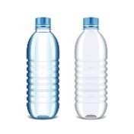

Cardboard

Paper
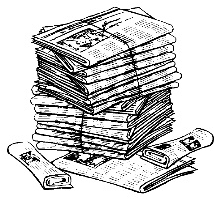

Glass
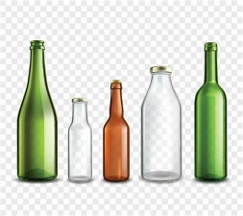

Cans
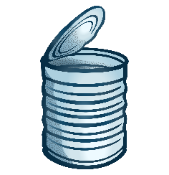

Anything else?

Use your findings to answer these questions.

- How many plastic items did you recycle?

- How many cardboard items did you recycle?

- How many paper items did you recycle?

- How many glass items did you recycle?

- How many tin items did you recycle?

- Which material was recycled the most?

- Which material was recycled the least?

- How many items did you recycle altogether?

