Home learning Week beginning 6 July 2020
Edison Year 1
Please look on the Home learning hub Class 1 for all the attachments. Thank you.
Remember to share your lovely work on the Padlet wall.
https://padlet.com/hkeane61/6j2p74ocw0ynvda6
Window walk’ Put your lovely things in your front window, so all your friends can see what you have been doing when they go for a walk.
Maths activities | Reading activities
Look on the previous Home learning plans for online maths games we have been using.  Use www.topmarks.co.uk to play different maths games.  Use your LGFL USO username and password to login to Busy things for lots of fun maths games.  https://www.busythings.co.uk/play/  NEW MATHS ACTIVITIES  Look on the HOME LEARNING HUB Class 1 for the Math’s worksheets and answers.  Monday Maths 1 Before and after  Tuesday Maths 2 Dates  Wednesday Maths 3 Time to the hour  Thursday Maths 4 Time to the half hour  Friday Maths 5 Writing time  Extra challenge- comparing time  (using < less than, > more than, = equals signs) | - Keep reading lots of different books at home.  - Please read every day and share a book with an adult.  - ‘Audible stories’ is a free website where children can listen to lots of different stories. You can use the link below.  https://stories.audible.com/start-listen  - Oxford Owl – use my class login. My Book shelf. Click on a book. Listen to the story and play activity 1 and 2.  NEW READING ACTIVITIES  Listen to The Lighthouse Keeper’s lunch by Ronda and David Armitage  https://www.youtube.com/watch?v=46wCRq50Wwg
Phonics activities | Writing activities linked to The Lighthouse Keeper’s lunch by Ronda and David Armitage
- Do phonics every day- Please see the attached phonics worksheet.  Remember to do your sound buttons and underline special friends. You can do a wiggly line to remind you to blend sounds. For example, br cr fl bl.  Remember to give yourselves a ‘rainbow clap’, a ‘Fan..tastic’! and a ‘hip, hip hooray’!  . | Monday  Listen to the story and talk about the settings. Use the worksheet HOME LEARNING HUB class 1 to draw and describe the settings.  Tuesday  What sandwich would you make to stop the greedy seagulls from eating Mr Grinling’s lunch? Draw and label your sandwich. Describe your sandwich. Use the writing sheet HOME LEARNING HUB class 1.  Wednesday  Plan your own delicious picnic lunch. Draw a picture and describe your picnic.  Thursday  Use the PowerPoint to find out about lighthouses.  Write 2 or more facts about lighthouses. Draw a picture.  Friday  Adjectives worksheet HOME LEARNING HUB class 1
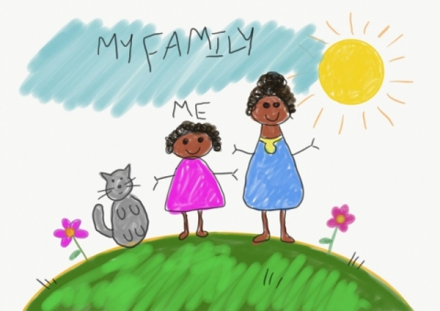
ART/DT 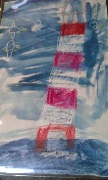 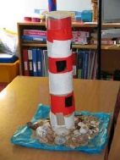
Make your own story puppets- use the story cut outs- HOME LEARNING HUB class 1.
Draw a lighthouse using wax crayons. Paint a blue wash over your lighthouse.
Design and make your own model of a lighthouse. You can use the lighthouse template (HOME LEARNING HUB class 1) or recycled materials.

OWL – Outdoor and wilderness learning ideas. Parents you can use the subscribe button on the hub and follow Forest school on social media (Facebook, Instagram, Twitter @forestschooling if able) to receive updates on the learning challenges.

https://owlfamily.co.uk/fun-things/
Sharing your lovely work!
Click on the Padlet link at the top to upload a photo of your work this week.
PLEASE REMEMBER NO NAMES OR PHOTOS OF CHILDREN- USE YOUR NUMBER.
To upload a photo of your work – open a text box. Remember to click on the pink round plus sign in the bottom right hand corner of the Padlet wall. Once you click on that pink sign your text box will appear. Now click on the first icon (an arrow pointing upwards) in your text box, ‘Pick file’ will appear, so you can find where you saved it on your computer. Select and upload it.
Coronavirus and Wellbeing- Looking Forward
The change that Covid-19 has caused to our lives has been difficult and has provided countless challenges. For many children, the uncertainty and disruption to everyday life has caused worry and anxiety. These tasks are designed to help children process the current situation, begin to make sense of it and plan for returning to a different normal.

Think
Reading or being read to offers hope and positivity. The Book of Hopes aims to comfort and encourage children during these unusual times.
Talk
Talk to your child about what they are looking forward to most when things begin to return to normal. Who are they looking forward to seeing at school? What places are they excited about visiting with the family? What will they miss about being at home?
Do
Write the headings ‘Things I’ve enjoyed being at home’ and ‘What I am looking forward to most’ on paper. Ask your child to draw and/or list all the positive experiences they have had over the last few weeks and those to come.
Visit
If your child is struggling to adapt to the ‘new normal’, Mind Ed for Families offers safe and reliable advice on supporting children’s mental health and wellbeing.

Please go to the Home learning Hub on the School website for further ideas.
You can contact me by emailing the school office.
Take care
Mrs Keaney

