Home Learning
WEEK 7
Y2
Weekly Maths Tasks | Weekly Reading Tasks
- Play on Daily 10 - play levels 1 or 2 to practise adding and subtracting.  - Practise counting in 2s, 5s and 10s. This game could support this. See attached worksheets to help.  - On a calendar (here is an online calendar if needed) go through and write down when different family members birthdays are or when special events are happening in your family.  - Practise telling the time in words. This could be done through this game (scroll down to access the game). Read to the hour, half hour and quarter past.  - Maths with Carol Vorderman  .https://www.themathsfactor.com/  https://www.thenational.academy/online-classroom/year-2/maths#subjects | - Find a book where you can see the characters celebrating. Is it a birthday? Can you read the book to someone over the phone?  - Create a celebration book with your family.  - Create a celebration reading den. What will you have in there? Who can read in there with you? Will you have cushions in there so you are comfortable?  - Read a poem about a celebration you have had or looking forward to celebrating with your family.  - https://www.thenational.academy/online-classroom/year-2/english#
Weekly Phonics/Spellings  Tasks | Weekly Writing Tasks
- Phonics play  - Top Marks  - Spelling  - Spelling City | - Write an invitation for a celebration. This could be a birthday party, family celebration etc.  - Create a list of all of the celebration days they can recall and write a sentence about what they remember about each.  - Invent a story involving a celebration. They could write it out or make a story map (attached). Encourage your child to use story language.  - Create a birthday card for the next family member’s birthday. Try and add a rhyming poem in the middle.  - Write a menu for a special celebration. It could be Christmas dinner or a Diwali feast.
Learning Project
What does celebration mean to you?

Watch with your child. Make an A-Z list of celebrations around the world. How many can they find?
What have they celebrated this year with their friends and family? Can they remember celebrating their birthday? How did they celebrate their birthday? Could they draw a picture of their special celebration? Can they interview a family member about their favourite celebration? What did they do? Who can they remember?

Create a celebration card for a family member. - What will they put on the front? Will it be pictures or will they write a birthday poem? Can they use different materials to design their celebration card?

Bake a cake: Weigh out the ingredients and bake a cake for a celebration. Can they write the instructions and send them to a friend? Can they email school with a photo of their cake and instructions? Upload to Padlet!

Design a celebration party: Ask your child to choose a celebration. Who would they invite? Get them to make a list of things they will need? (banners, balloons etc...) Would they have to have a dress code? Can they design a celebration invite? On a piece of paper can they think about the colours and pictures they may have.

Months:
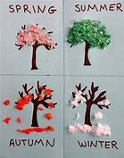
Can your child name the months in order? What do they notice about them? (Look at the letters at the beginning of the month.) Can they think of a celebration for each month they may have with their family? Find out when it’s people's birthdays or anniversaries. Which month has the most celebrations?

Seasons: Ask your child how many seasons we have? Can they name them?
Watch 1 Watch 2 Ask them to look outside their window and see if they can name the season we are in at the moment. What can they see? Can they see any flowers? Or new buds? Can they draw a picture of what they can see using different materials?

Calendar: Collect some materials to create a Seasons Calendar. Think about the design and what they will need.

Spring is in the air: Spring is around us: Can they look around the house to see what they can use to make a crafty spring project.

Celebrations across the four season:
Think about all of the celebrations we have around the world. Can they name them and place them into the correct seasons?

Autumn: Diwali, Bonfire Night, Harvest Festival , Hanukkah
Winter: Christmas, New Year
Spring: Holi, Easter, Mother’s day
Summer: Father’s day, EID, Vesak

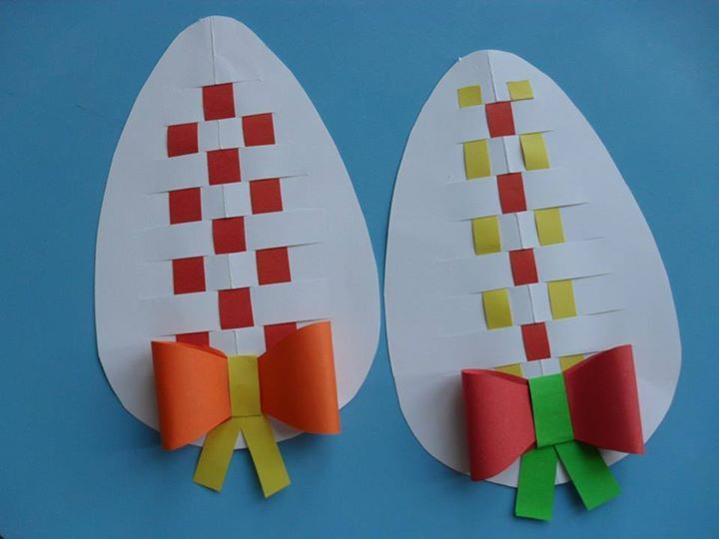
Create a card for each of these celebrations. How will their designs be different? Are there particular colours they can use? Could they make a pop up card? Could they make a card using no pen and only fabric?

Traditional celebration: Talk to an adult and ask about any traditional celebrations you may have as a family. Why do you celebrate them? How do you celebrate them and when?
Do you have to wear different clothes and eat different food?

Gather the family and sing the song ‘Celebration’: Can you add actions to the dance? Could you have a concert and perform to your family and friends?

Additional learning resources parents may wish to engage with:
Twinkl - to access these resources click on the link and sign up using your own email address and creating your own password. Use the offer code UKTWINKLHELPS.

https://padlet.com/mbrierley3314/ey7vchke0gtujucd

