Home learning – WEEK 5
Edison Year 1
Remember to share your lovely work on the Padlet walls.
https://padlet.com/hkeane61/dprmb3evliarln4r

https://padlet.com/hkeane61/bkhdwotdsjj7lg7a

Window walk’ Put your lovely things in your front window, so all your friends can see what you have been doing when they go for a walk.

The Archbishop of Canterbury, Justin Welby assembly is streamed live between 10am- 11am on Oak National Academy. There is an assembly tab for each year group.

Maths activities | Reading activities
Below is a reminder of a few of the online maths games we have been using.  - Recognise the place value for numbers up to 99 in this place value basketball game.  - Use www.topmarks.co.uk to play different maths games.  Daily 10 mental maths challenge – Start with level 1. Addition subtraction and ordering.  https://www.topmarks.co.uk/maths-games/daily10  Addition and subtraction ladder  https://www.topmarks.co.uk/Search.aspx?q=Addition%20and%20subtraction%20ladder  Chopper squad  https://www.topmarks.co.uk/learning-to-count/chopper-squad  NEW MATHS ACTIVITIES  - Start by choosing a number between 10 and 20. Show how your chosen number can be partitioned into tens and ones. You can use objects to help you.  For example, 14 can be partitioned into1 ten and 4 ones.  Now choose a bigger number and work out how the number can be partitioned into tens and ones.  - Use 2p 5p 10p coins to help you count in 2s 5s and 10s.  - ‘Measuring in centimetres’- learning to use a ruler.  https://www.topmarks.co.uk/maths-games/measuring-in-cm  - ‘Blast Off’ Find a number or count on and back  https://www.topmarks.co.uk/learning-to-count/blast-off  - Play ‘Coconut odd or even’  https://www.topmarks.co.uk/learning-to-count/coconut-odd-or-even  Use your LGFL USO username and password to login to Busy things for lots of fun maths games.  https://www.busythings.co.uk/play/  This week we will be learning about mass.  Please see the attached maths worksheet on mass. | - Keep reading lots of different books at home.  - Please read every day and share a book with an adult.  - ‘Audible stories’ is a free website where children can listen to lots of different stories. You can use the link below.  https://stories.audible.com/start-listen  - Oxford Owl – use my class login. My Book shelf. Click on a book. Listen to the story and play activity 1 and 2.  NEW READING ACTIVITIES  - Read and write the numbers 1- 20 in words. Play Bingo using the words.  - Keep looking at the words on your ‘Tricky word’ mat.
Phonics activities | Writing activities
- Do phonics every day- Please see the attached phonics worksheet.  Remember to do your sound buttons and underline special friends. You can do a wiggly line to remind you to blend sounds. For example, br cr fl bl.  Remember to give yourselves a ‘rainbow clap’, a ‘Fan..tastic’! and a ‘hip, hip hooray’!  - You could watch Mr Thorne’s phonics with Geraldine the giraffe on YouTube.  - Use these Interactive games found on the links below.  - Phonics play  - Top Marks  - Spelling  https://www.teachyourmonstertoread.com/  Handwriting  Please see the attached handwriting sheets to help children remember where to position ascenders and descenders. | This week I would like you to interview a member of your family.  You could interview someone who doesn’t live with you and FaceTime them with your questions!  Think of up to 5 questions you would like to ask and write them down. For example, find out their full name, age, where they live, what it was like for them as a child, if they have they done anything exciting in their lives, their careers etc..  Write up 2 or 3 (or more) of the facts you have found out and draw a picture of the person you interviewed.  Now find out about why our class is named after Thomas Edison.  Use the PowerPoint to find out about Thomas Edison.  Write about Thomas Edison and draw a picture of the things he invented.
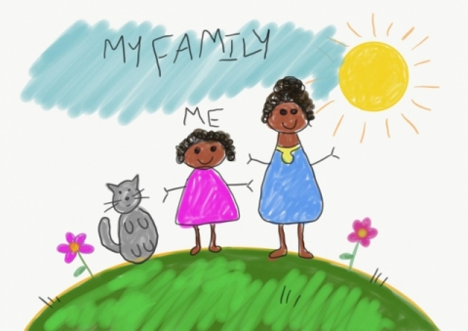
RE Why do Christians make and keep promises before God?
Talk about how the children belong to different groups. For example, St John’s school, St John’s church, other faith communities, Beavers, Rainbows, sports clubs, friendship and family groups.
Talk about how they feel belonging to the different groups. Reflect on how it might feel to be left out and not belong to anything.
Draw a picture to show one of the groups they belong to and write a sentence to say how they feel belonging to that group.

Art/DT
Weaving. Make a weaving loom – by folding and cutting slits in a piece of paper or wrapping string/ wool around card/paper plate or a recycled container. Use twigs or a garden fence! Weave natural or man-made materials to create a pattern, a shape or a picture.
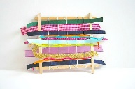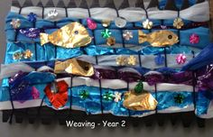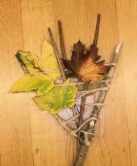

SCIENCE
This week we are continuing with our topic on plants. Use the attached science sheet to begin to identify and name common wild plants. Look out for these wild plants when you go out for a walk. Watch the link below about plants.

https://www.bbc.co.uk/bitesize/topics/zpxnyrd/articles/zw2y34j

GEOGRAPHY
Find out the difference between a human and physical feature.
A human feature is something man- made or it was made by a human being. For example, a building, a bridge or a road because they were made by a human being.
A physical feature is something which is natural – it happens naturally. For example, a river, a cliff or a beach.
Watch this short video on the United Kingdom.
https://www.bbc.co.uk/teach/class-clips-video/geography-ks1--ks2-the-united-kingdom/zhtgrj6

This video will remind you of what we have already learnt in class about the four countries which make up the United Kingdom, as well as the capital and flag of each country.
It will also show you a key human and physical feature of each country.

After watching the video can you answer these questions:
What are the four countries of the United Kingdom?
What are the capital cities of each country?
What is a human feature? Can you give an example?
What is a physical feature? Can you give an example?
Draw your own human feature and a physical feature or one that you saw in the video clip.
OWL – Outdoor and wilderness learning ideas. Parents you can use the subscribe button on the hub and follow Forest school on social media (Facebook, Instagram, Twitter @forestschooling if able) to receive updates on the learning challenges.

https://owlfamily.co.uk/fun-things/

Sharing your lovely work!
Click on the Padlet link below to upload a photo of your work this week.
PLEASE REMEMBER NO NAMES OR PHOTOS OF CHILDREN- USE YOUR NUMBER.
To upload a photo of your work – open a text box. Remember to click on the pink round plus sign in the bottom right hand corner of the Padlet wall. Once you click on that pink sign your text box will appear. Now click on the first icon (an arrow pointing upwards) in your text box, ‘Pick file’ will appear, so you can find where you saved it on your computer. Select and upload it.

Please go to the Home learning Hub on the School website for further ideas.

You can contact me by emailing the school office.

Take care
Mrs Keaney

