St John’s Church of England Primary School

Wks 29th-10th July 2020: Nursery and Reception Learning Project - Under the Sea
Reading Tasks | Phonics Tasks
Monday- Share the story ‘The Snail and the Whale’. If you don’t have a copy at home watch this online reading. | Monday- Ask your child if they can hear the sounds that come at the beginning of snail and whale. Can they think of/ or find other things that begin with the same sound? They could create a poster or take photographs of the things they see.
Tuesday- Reception age children: Children to read to parents daily. Visit Oxford Owl for free eBooks that link to your child’s book band. Complete the linked Play Activities for each book. | Tuesday- Buried Treasure: Write out some real words and made up words (e.g. tud, jup, fub). Place these in a pile and using 2 containers, label one as ‘Treasure’ and the other as ‘Bin’. Can your child read the word and decide if it is real? If it is real it goes in the treasure chest, if not it goes in the bin. Simplify this activity for Nursery by sounding the words out for them.
Wednesday- Read a variety of books at home in different places. Favourites can be repeated. Hearing the patterns of language in a story will support your child’s language development. | Wednesday- Play Buried Treasure online on PhonicsPlay.  Check out Ruth Miskin ‘Read, Write Inc’ videos for set 1 and 2 sounds leant I in Hubble class this year.  Set 1- https://www.youtube.com/watch?v=hCBzNnSSxds  Set 2- https://www.youtube.com/watch?v=p7hRbrpq5Bo
Thursday- Watch the online storybook- ‘Sharing a Shell’. Discuss how the crab felt in the story at each stage. Your child could draw a picture to represent the crab’s feelings. | Thursday- Sing ‘1,2,3,4,5 Once I caught a fish alive’. Click here for the words. Can your child learn this by heart?
Friday- Ask your child to look at the books you have in your house. Can they find any other books about creatures that live under the sea? Can they group the animal books e.g. farm animals, jungle animals, under the sea animals? | Friday- Play Fish for Sounds – write out some letter sounds that correspond to objects found in the sea – sh for shell, f for fish. Try and write them outside in chalk or similar and encourage your child to trace over them.
Writing Tasks | Maths Tasks- Making Simple Patterns
Monday- Ask your child to draw a picture and write about their favourite underwater creature. Rec-They could label the picture too. | Monday- Can your child join in with tongue twisters: red lorry, yellow lorry, red lorry, yellow lorry?
Tuesday- Have a try at Snail Writing. Using hair gel, shaving foam or any other slimy liquid, show your child how to form the letter ‘s’ using your finger. If your child can, ask them to try the word ‘snail’. Repeat for other words. | Tuesday- Ask your child to make a simple shape pattern or a colour pattern by visiting String of beads CHALLENGE: Make your own repeating pattern.
Wednesday- Ask your child to close their eyes and imagine being at the beach. Can they draw a picture list or, if they are able, use their phonics to write a word list of all the things you can see, taste, touch, smell and hear? | Wednesday- Can your child make a repeating pattern using objects around the house/garden i.e. apple, banana, apple, banana. CHALLENGE: Ask your child to build on the above to create more complex patterns e.g. apple, apple, banana,
Thursday- Use this animated letter formation tool to help your child practice letter formation. You can select those they find most challenging. Nursery-practice your name | Thursday- Ask your child to create repeating patterns with actions: Clap hands, tap knees, clap hands, tap knees. Make your own action patterns. CHALLENGE: one person makes the action pattern; the other person is to listen and repeat
Friday- Listen to the song Henry the Crab- Rec- Ask your child to draw a picture of what they think Henry the crab looks like.CHALLENGE- Can they write a letter to Henry and ask him about what it is like to live under the sea? | Friday- Draw the outline of a fish for your child to make a pattern in. Could they make the pattern out of 2D shapes? Can they make a repeated pattern?
Learning project
The project this week aims to provide opportunities for your child to learn more about life in and around the sea. Learning may focus on the strange and wonderful creatures and plants that occupy our oceans, their habitats and how human beings affect this environment.

After listening to the story, ‘The Snail and the Whale’ (see reading task).
- Take your child on a snail hunt around the garden. Can they think about the places a snail might want to live?
- Show your child a picture of a sea snail. Ask, how is it different from the snails they found in the garden?
- Have a Snail Race- Use chalk to draw out lines on the ground (or sticks to mark out the lines) to create a race track. Place your snails at the starting line and watch them go! You could give your child a timer to measure how long it takes for the snails to make their way across. Share a picture of the winning snail on Twitter at #TheLearningProjects

Make your own ‘Under the Sea’ Scene
- Watch this video of the coral reef. Talk about the animals you can see. What are the animals called?
- Use junk modelling or craft items you have around your house to create the scene. You could even add in natural objects e.g. grass as seaweed.

Counting Undersea Creatures
- Show your child how to play this game. There is a simpler version with amounts to 5 and a more challenging version with amounts to 10. CHALLENGE: Support your child to create a record of how many of each creature there were.

Make your own Fishing Game
- Make a fishing rod using a stick or similar (a wooden spoon would work well!). Tie some string on to one end and tie a magnet onto the end of the string (you could use a fridge magnet).
- Using the rod, your child could explore which items are attracted to the magnet around the house

Explore Floating and Sinking
Fill up a bowl, sink or basin and provide your child with a range of objects to explore. Which one’s float and which sink? Ask them why they think they float/ sink? CHALLENGE: Keep a record of the objects that float and sink? This could be using pictures or written.

STEM Learning Opportunities #sciencefromhome
Unplugged Coding
Watch this video. - Rec
Create a simple under the sea obstacle course or draw an obstacle course on a piece of paper. Children have to guide an under-water robot (Parent/sibling/toy) through the obstacles by shouting out simply instructions. E.g. forwards, right, left, backwards.
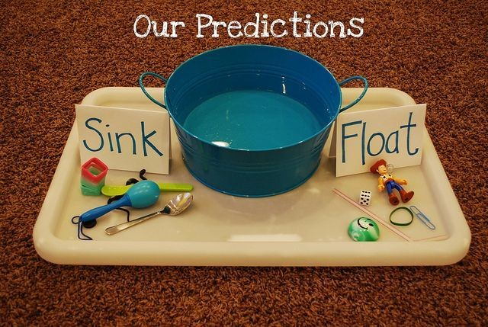

Additional learning resources parents may wish to engage with
White Rose Maths online maths lessons. Watch a lesson video and complete the worksheet (can be downloaded and completed digitally).
IXL Click on Maths, Reception. There are interactive games to play and guides for parents.
https://www.thenational.academy/online-classroom/subjects/#subjects

